**Capestone Project**

**Introduction/Business Problem:**

If a Businessman has a successful restaurant at a place in a city, He would tend to open his next restaurant at place similar to the successful restaurant’s place in another city.

Let’s assume I have a successful restaurant in Madhapur , Hyderabad. I am willing to open a restaurant in Central Bangalore neighborhood which is like Madhapur.

Aim: The goal is to find which neighborhood of Central Bangalore is like Madhapur , Hyderbad.

**Data:**

First, I will be needing latitude and longitude of Madhapur. I will use geopy library to get the latitude and longitude. Then I will be querying nearby places data from foursquare API.

Then I will use beautifulsoup library to get neighborhood places of Central Bangalore. For each place I would using geopy library to get latitude and longitude and foursquare API to get nearby places and concate them into single pandas data frame.

**Methodology:**

1. First I will collect the nearby data of Madhapur using Foursquare API.
2. Then I will get the region in Central Banglore neighbourhood using BeautifulSoup
3. Then I will get nearby data of every region in Central Bangalore and append them to a data frame.
4. Then I will append Madhapur data.
5. Then Preprocess the data to perform K-Means Clustering
6. Perform K-Means Clustering and find which region is more like Madhapur

**Results:**

After performing the Clustering, I found that Vansanth Nagar in Banglore is more likely to Madhapur Hyderabad.

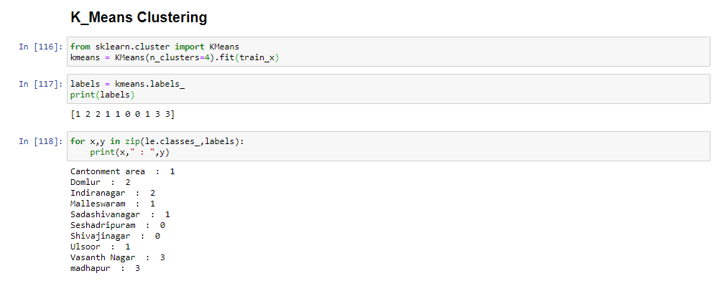

**Discussion:**

Vasanth Nagar should be our first choice. But Incase building a restaurant in Vasanth Nagar is not possible then we need to build at Seshadripuram or Shivajinagar (use k=3 in clustering, you will find these in same cluster as Madhapur).

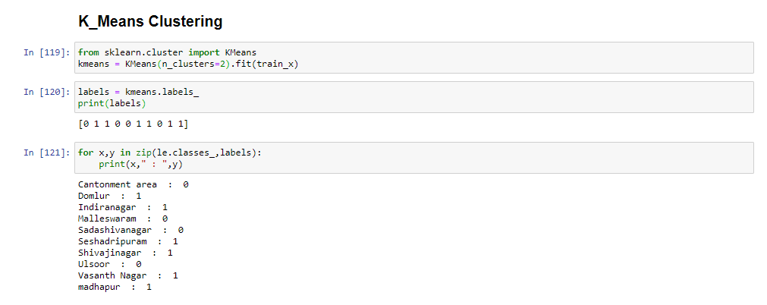

**Conclusion:**

The new restaurant should be built at Vasanth Nagar. If not possible then Seshadripuram or Shivajinagar should be our second choice.